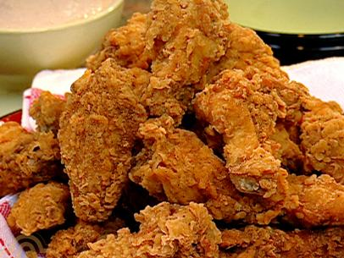
PAT NEELY’S SPICY WINGS

Ingredients
- Blue Cheese Dipping Sauce:
- 1/4 cup Danish blue cheese, crumbled
- 1/4 cup buttermilk
- 1/3 cup sour cream
- 1/4 teaspoon sugar
- 2 teaspoons apple cider vinegar
- Salt and freshly cracked black pepper
- Seasoning:
- 2 teaspoons Neely's Dry Rub
- 2 teaspoons kosher salt
- 1/4 teaspoon cayenne pepper
- Peanut oil, for frying
- 3 pounds chicken wings, cut at joint, washed and dried
- 1 to 2 tablespoons lemon-pepper seasoning
- 4 tablespoons salted butter
- 1 clove minced garlic
- 1/2 cup hot sauce (recommend: Texas Pete's)
- 2 tablespoons brown sugar
- 1 tablespoon apple cider vinegar
- 1/4 teaspoon Worcestershire sauce
- Carrot and Celery Sticks, for serving

Directions
.For the dipping sauce:
- In a small bowl, mash the blue cheese into the buttermilk and sour cream. Mix in the sugar and the apple cider vinegar, and season with salt and pepper, to taste.
- For the seasoning:
- Mix the dry rub, salt, and cayenne together in a small bowl.
- Preheat deep-fryer with peanut oil to 350 degrees F.
- For the wings:
- Add the wings to a large mixing bowl and season with the lemon-pepper seasoning and toss to coat. Allow to sit for a few minutes, so flavors can permeate into the chicken.
- Add the wings to the deep-fryer and fry until cooked through and golden and crisp, 12 to 15 minutes. You may need to do this in batches.
- Meanwhile, while wings are frying, melt butter in small saucepan over medium-low heat with the garlic. Transfer to a large bowl and whisk in the hot sauce, brown sugar, vinegar, and Worcestershire sauce until combined.
- Remove wings from fryer and drain on a paper towel lined sheet tray. Immediately sprinkle with the seasoning.
- Add fried wings to the large bowl of sauce and toss until well combined and wings are well coated. Serve immediately after tossing the wings with the sauce. Serve with the blue cheese dipping sauce and celery and carrot sticks.

